1. **Scenario 1:**

**Employee Data Management**

* + You are tasked with creating a program for a small company’s HR department to manage employee data efficiently. The program should allow the HR team to:

1. Enter employee details (name, ID, salary).
2. Save the data in a binary file to ensure security and prevent accidental corruption.
3. Retrieve and display the saved employee data when needed.

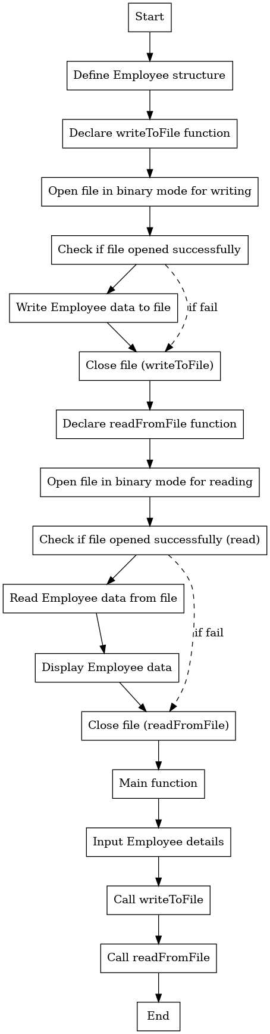

Author : Aishwarya K Manager - Program Delivery (CyberSecurity)

# Scenario:

Imagine you are developing a simple tool for a mathematics tutor who frequently needs to calculate factorials for their lessons. The tool should allow the tutor to input a positive integer and display its factorial. However, the tool should also account for invalid inputs, such as negative integers, by providing an appropriate message instead of attempting to compute the factorial.

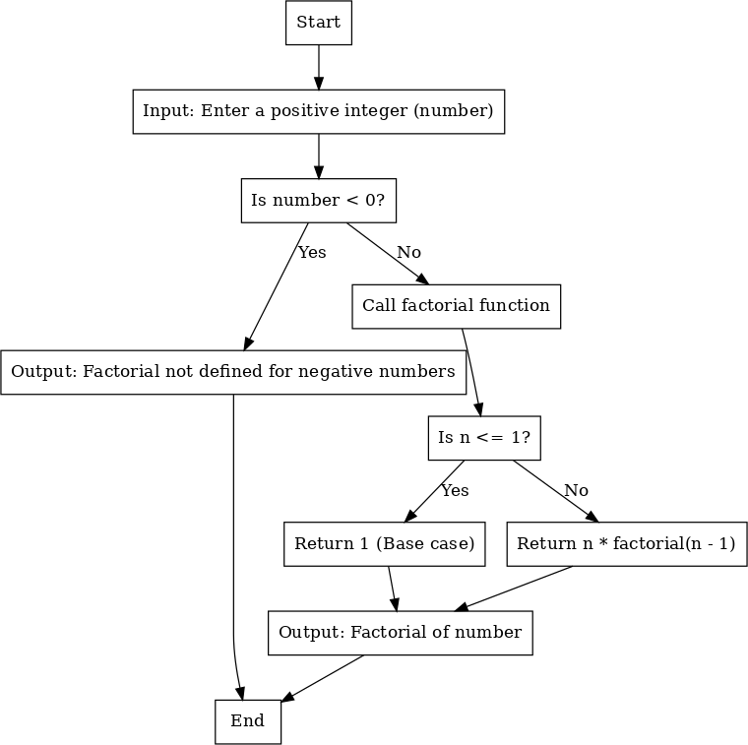

# Scenario:

You have been hired as a software developer at a small company, and your first task is to create a **Simple Calculator** application that will allow users to perform basic arithmetic operations. The calculator will prompt the user for two numbers and allow them to choose one of four operations: Addition, Subtraction, Multiplication, and Division. You are tasked with implementing this application in C++. The program should handle user inputs for the two numbers and the operation to perform. If the user attempts to divide by zero, the program should show an error message indicating that division by zero is not allowed.

